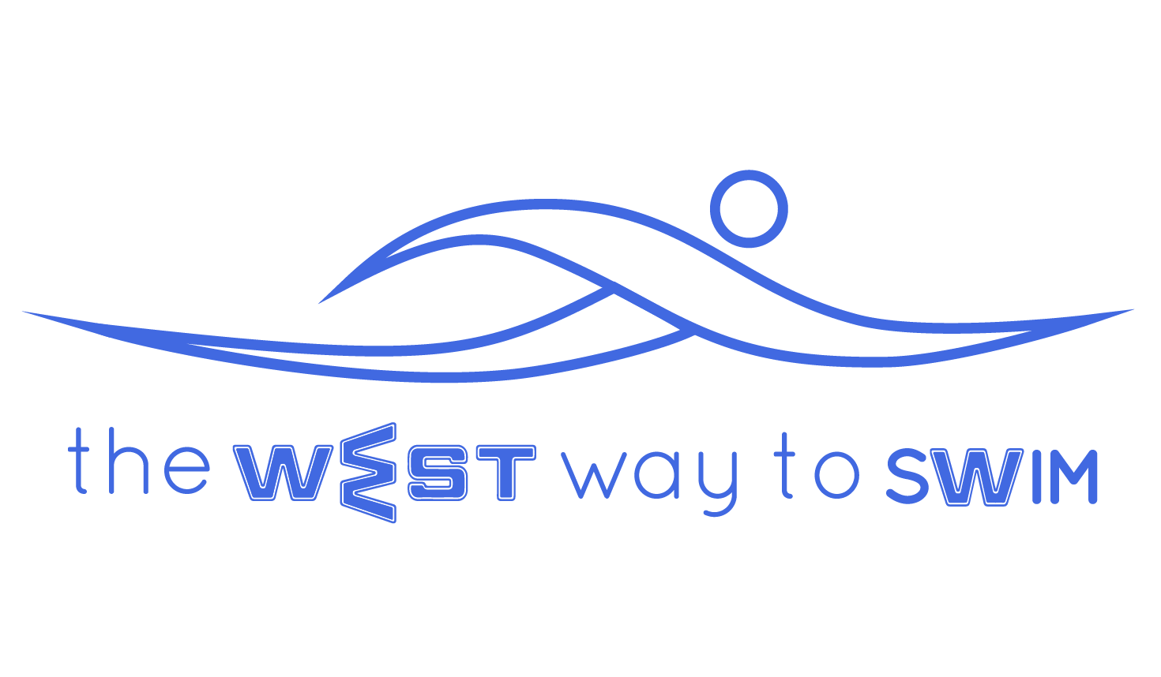
3.0 The goal of session # 3: Mastering correct body position and timing of breath in freestyle, learning double arm backstroke and understanding how to remain buoyant in the water.
No | The Drill & Goals | Duration in min | WEST Key Principles | From theory to practice
3.1 | Revision of two key principles (KP1+5) with and without fins, without breathing | 10 |  | Swim Freestyle without breathing 10-12 meters at a time. 5 minutes without fins and 5 minutes with fins. While swimming, keep focus on the two key principles of the WEST Technique- Shape of palm and depth of stretch.
3.2 | Revision- Freestyle with fins - rotation to supine position every third stroke.  (Drill 2.6). | 6 |  | Revision of swimming freestyle with fins and rotating to supine position every 3rd stroke, it is important not to strain the neck during the rotation and ensure palm turns to the sky in supine position.
3.3 | Freestyle without breathing, 3 buoyancy principles and release of the spine. | 6 | KP-6 -3.31 - Drag legs  KP- -3.32 - Head position in water  KP-13- 3.33 - Duration of glide in water | Swim Freestyle without breathing while keeping in mind a different key principle every 2 minutes (according to personal WEST).  KP6 - Dragging legs:  Gently kick with legs, just enough to keep them buoyant (not in order to progress) and prevent the pelvis from stiffening up.  B or C Do not kick, allow extension of the arm to move the legs.  KP8 - Head position:  A - Gentle tilt of head downwards.  B or C - Neutral head with eyes fixed towards the floor.  KP13 - Duration of glide:  A - Glide 3 seconds from the moment your palm touches the water’s surface.  B - Glide 2 seconds until shoulder touches 1/2 chin -1/2 cheek.  C - Glide 1 second till shoulder touches cheek.
3.4 | Body position while breathing at 90 degrees + fin stretch at end of every 50 meters. | 8 | KP 12- Body position when breathing at 90 degrees | Swimming Freestyle with fins, right arm stretched in front, the other arm besides the body, body positioned at 90 degrees with one eye in the water and one eye out the water, nose and mouth out of the water. After 25 meters, change sides. At the end of 50 meters, fin stretch for 10 seconds each foot.
3.5  3.5.1  3.5.2 | Freestyle with fins, breathing every 2 strokes (one length breathing right, one length breathing left).  Correct timing, every breath- glide for 3 seconds.  Exhale with bubbles according to personal WEST | 8 | KP10- Timing of breath  KP11- Bubbles | Swim Freestyle with fins, breathing every two strokes - One length breathing only left, and the next length breathing only right. On every breath remain in breathing position for 3 seconds (while gently kicking).  3.5.1 - Timing of breath:  A - Before leading arm enters the water, begin to rotate body (not just neck) in the direction of the breath.  B - Once the leading arm enters the water, begin to rotate body (not just neck) in the direction of the breath.  C - When the leading arm is extended and the elbow is in the water, begin to rotate body (not just neck) in the direction of the breath.  3.5.2 - Blowing bubbles-  A - Hold breath and exhale only during rotation and before inhalation.  B - Exhale from nose only while head is in the water.  C - Exhale from nose and mouth while head is in the water.
3.6 | Freestyle with no fins and no breathing - elbow raised according to personal WEST | 5 | KP3- Height of elbow | Walking for a few meters with chest submerged in the water. Raise elbow to maximal height and lower a little. Once you have felt and comprehended your personal WEST, swim without breathing or fins.  Raising the elbow:  A with lower back pain - swim with straight arms, do not raise elbow.  A without lower back pain - raise elbows a little above the water.  B - Elbow at half of maximal height.  C - Raise elbow to maximal height (shoulder almost touches ear)
3.71  3.72  3.7.3 | Freestyle breathing every 3 strokes (slow inhalation)  Double arm backstroke with fins (recovery)  Leg stretches | 8  2  6 | 3.7.3.1 - Ankle stretch  3.7.3.2 - Hamstring stretch  3.7.3.3 - Groin stretch | 3.71- Swim freestyle with a slow rotation and inhalation every third stroke. Additionally, count how many strokes you do in 25 meters. Between lengths, rest and stretch.  3.72- Double arm backstroke: Lie in supine position with arms besides the body. Together with slow inhalation raise palms along sides of the body until thumbs touch armpits. Stretch arms to the side in a T shape and then, exhaling through the mouth, lower straight arms back towards sides, kicking gently with the fins.  3.7.3 - Stretches:  Perform each stretch for exactly 2 minutes (6 minutes altogether):  3.7.3.1 - Ankle stretch- place heel on the floor, toes extended on the wall and lean body forward towards the wall. After 10 seconds - change legs.  3.7.3.2 - Hamstring stretch - Place leg at hip height on a step or a chair, with other leg on the ground and knees straight, and try to bring your head towards the extended leg.  3.7.3.3 - Groin stretch - In the starting position of 3.7.3.2, take one step back with the standing leg, and slowly lower groin toward the floor. If you don’t feel the stretch, try to take the leg farther back.
3.8 Weekly Tip: Your breathing in freestyle will improve due to the buoyancy principles. The more buoyant your body is, the easier it is to breath. Therefore, do not insist on breathing, just keep in mind your personal WEST key principles and your buoyancy and breathing will improve.

